**Chapter 2 - Computational Thinking and Algorithms**

**What is a computer?**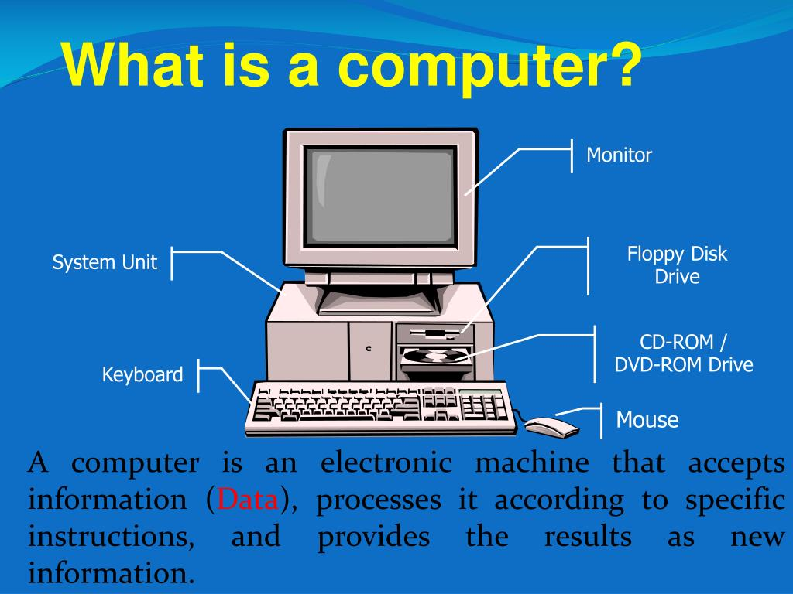

A computer is a machine that is used to solve problems by accepting inputs, performing operations and presenting outputs.

**2.1 Problems**

A problem is a challenge that needs to be overcome by taking action.

Problems are present in all fields and sectors like healthcare, economics, education and infrastructure etc.

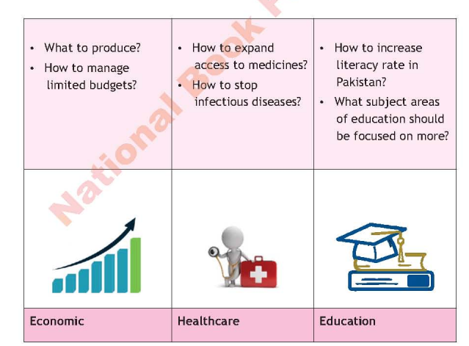

Examples of Problems in Different Fields

**2.2 Identifying a Computing Problem**

In computer science, a problem that is solved step by step using computation is called a *Computing problem.*

It can include calculations (arithmetic or logical). These problems have a well defined input and some desired outputs that must be satisfied. Some examples of computing problems are:

* Decision Problems
* Search Problems
* Counting Problems

1. **Decision Problems**

A decision problem occurs when a given input requires a binary response, either *Yes or No*, which can also be in the form of *True or False.* In complex cases the answers are usually longer than *Yes or No.*

Examples:

* The problem is whether a given number is odd.
* The problem is that is there any occurrence of “aa” in a sequence of **X** English alphabets.

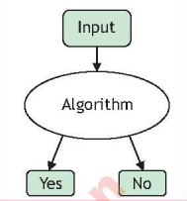

1. **Search Problems:**

In such types of problems, we have a set of objects among which we search for solutions. Search problems are repeated using graphs, where there are *nodes* and where each link connects to nodes. *A node can be connected to multiple nodes.*

To solve search problems, we have three things

1. **Initial State:**  This represents the node from where we need to start the search.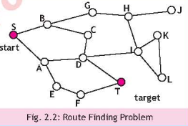
2. **Operations:** This represents the moves that transition from one node to another.
3. **Goal:** It defines the target at the end.

*Example*

**3. Counting Problems:** These problems work on the principle that if a decision has **A** number of choices and another decision has  **B** number of choices then the total number of possible unique combinations would be A x B

**Example:** One event is a number of shirts, and another event is the number of pants you own, then how many pairs of shirts and pants you can make from it?

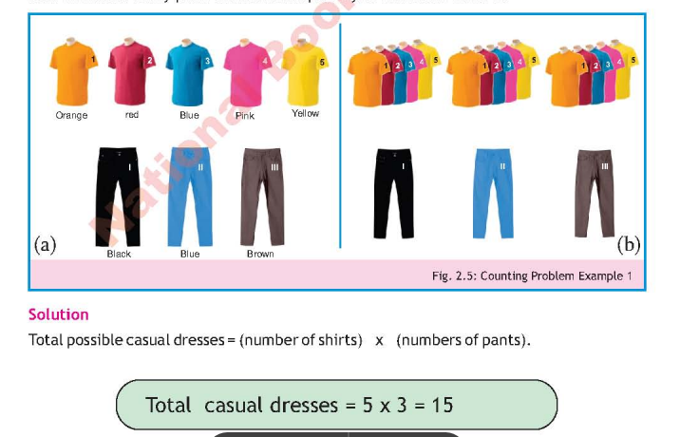

**2.3 Problem Solving**

*Problem solving is the process of analysing some situations and generating a response accordingly.*

*For Simple Problems:*

The following 4 steps are used:

1. Define and analyze a problem: what is the problem and why is it happening?
2. Design a plan: What we are going to do? (Algorithm)
3. Implement the Plan: Code it by using some programming language.
4. Evaluate: did our plan work?

*For Complex Problems;*

The 6 step problem solving process could be used:

1. Define and analyze a problem
2. Decompose the problem: make sub-problems that are manageable
3. Identify plans for each sub-problem
4. Select and design the best plan
5. Implement that plan
6. Evaluate.

Before solving a problem, all aspects must be investigated and so a problem must be properly defined through objectives and analysed.

### **2.4 Input-Processing-Output (I-P-O) Model**

All computer systems work on an **Input-Process-Output model**.  
Its **purpose is to analyse** problems by breaking them into input, output and processing. For this, the following should be correctly identified:

* Input - which is given to the system
* Operations - the system performs
* Output - that is presented at the end



### **2.5 Input-Processing-Output (I-P-O) Chart**

The visual representation of the IPO model is done using the I-P-O chart, through which inputs, outputs and processes are represented.  
It is a handy tool for software designers to solve problems.  
  
**IPO Chart**

| **Input** | **Process** | **Output** |
| --- | --- | --- |
| Data entered in the system | Operations that will be applied on the input | Data that has been turned into information |

**Example of an I-P-O Chart to calculate the area**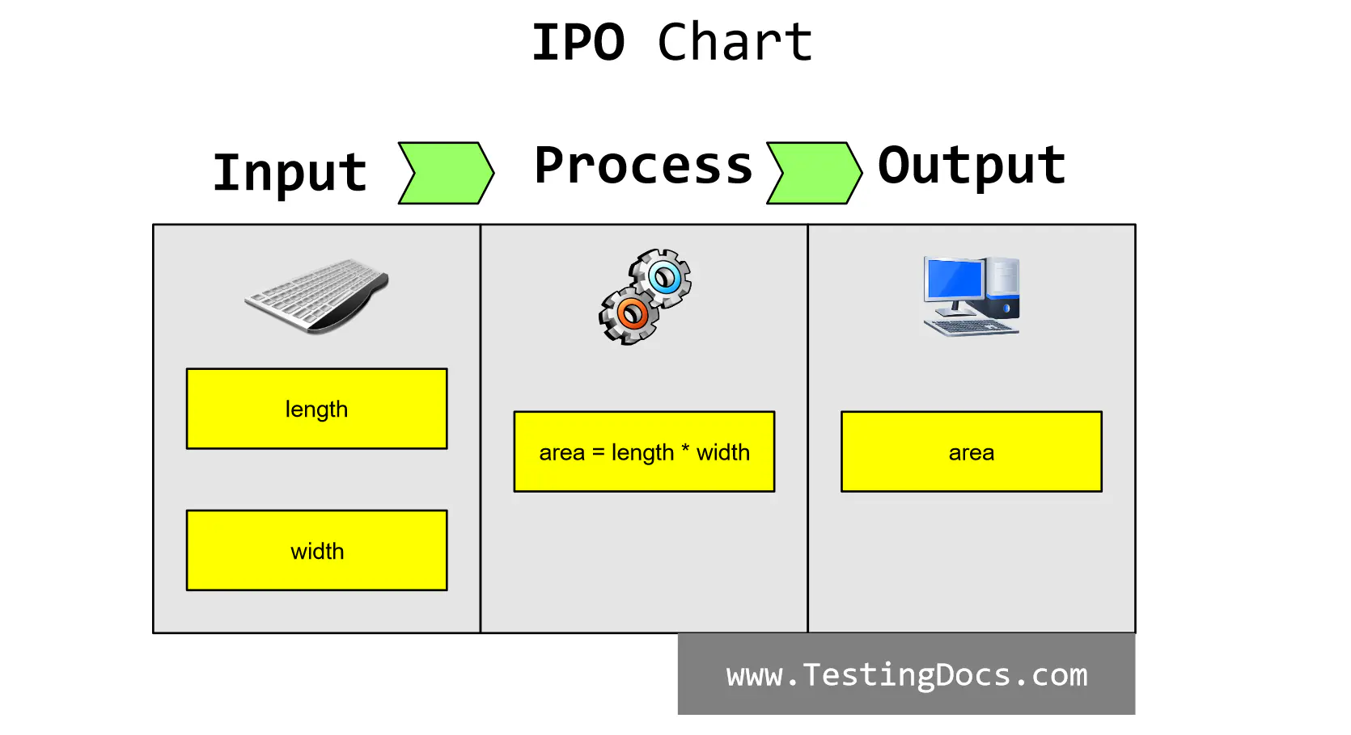

### **2.6 Computational Thinking**

Using computation to solve problems requires the ability to think in a certain structured way, which is referred to as **computational thinking**.

### *Importance of Computational Thinking*

Computational thinking is not just about solving one problem but about creating repeatable solutions. It helps design an automated system that can solve similar problems. This approach is an extension of logical thinking, emphasizing defining clear steps and ensuring the solution works for all instances.

### 

### 

### ***There are certain properties of Computational Thinking:***

* **Decomposition**: Breaking a large problem into smaller, manageable sub-problems to simplify and solve them more easily.
* **Abstraction**: Removing unnecessary details to focus only on essential information.
* **Pattern Recognition**: Identifying patterns or similarities in previously solved problems to help with the current one.
* **Algorithm Design**: Creating a step-by-step plan to solve the problem systematically.

### **Principles of Computational Thinking**

There are two principles used in computational thinking:

1. Logical Thinking
2. Algorithmic Thinking

* **Logical Thinking**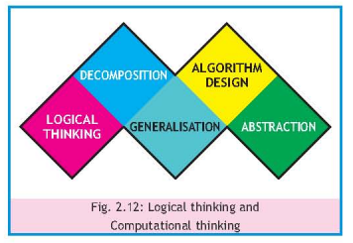

Logical thinking is a key principle, involving the ability to analyze a situation or problem using reasoning and evidence. It helps in making decisions based on facts. Logical thinking requires gathering relevant data and making sensible decisions.

Example of Logical Thinking:  
 If you see water on the floor when you enter your home, you gather facts and infer possible reasons based on evidence.

* **Algorithmic Thinking**

Algorithmic thinking is a method to solve problems by identifying and logically implementing efficient steps.

An example is finding the largest of three unequal numbers using an IPO chart:

| Input | Process | Output |
| --- | --- | --- |
| Three Numbers | Find the largest amongst the three | Display the largest |

The algorithm for the process part:

**Step 1:** Let three number be A=10, B=20 and C=30

**Step 2:** Check if A is the largest?

*Step 2.1:* Check if A > B and A > C then A is the largest.

**Step 3:** If A is largest then Stop the process, otherwise proceed to the next step.

**Step 4:** Check if B is largest?

*Step 4.1:* Check if B > A and B > C then B is the largest.

**Step 5:** If B is largest then Stop the process, otherwise proceed to the next step.

**Step 6:** C is largest.

**2.8 Methods to Design a Solution**

After understanding the problem, the next stage is to design the solution, in which you define how a software will meet the requirements and objectives of the problem.

*Flowcharts and Concept Maps are used to design solutions*

**Flowcharts**

Flowchart is a diagrammatic representation of an algorithm. It describes what operations are required to solve a given problem.

*Importance of flowchart in solving a problem*

A flowchart illustrates the sequence of operations to be performed to solve a problem in the form of a diagram.

It is very helpful in communicating the problem-solving method to other people. It also helps in finding and removing logical errors.

***Steps for drawing a Flowchart***

The following requirements for the given problem must be determined before drawing a flowchart:

* Start of the flowchart
* Input to the flowchart
* Type of processing required
* Decision to be taken
* Output of the operation
* End of the flowchart

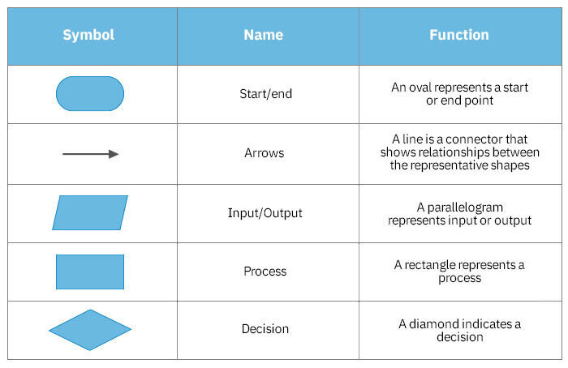

**Example:** Flowchart to find the largest between three numbers

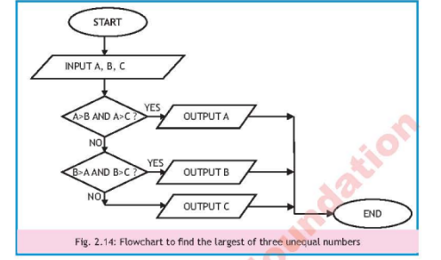

Software Tools for Flowchart Designing

Different software tools are available to design the flowcharts, for example *Microsoft Visio and LARP software.*

Microsoft Visio is a tool for drawing various types of diagrams such as flowcharts, building plans, data flow diagrams, network diagrams, etc.

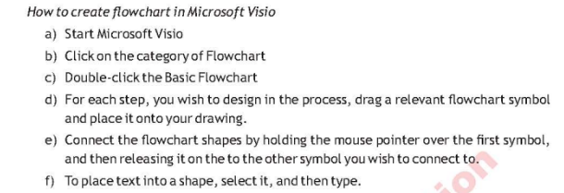

**Logics of Algorithms and Resolution of Problems (LARP)** also allows algorithms to be expressed as flowcharts. 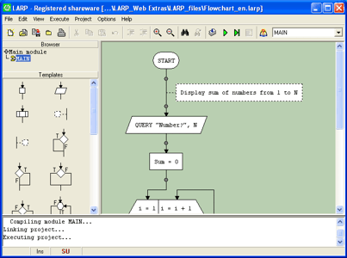

**Concept Maps**

A concept map is a graphical tool that represents concepts and relationships between them. 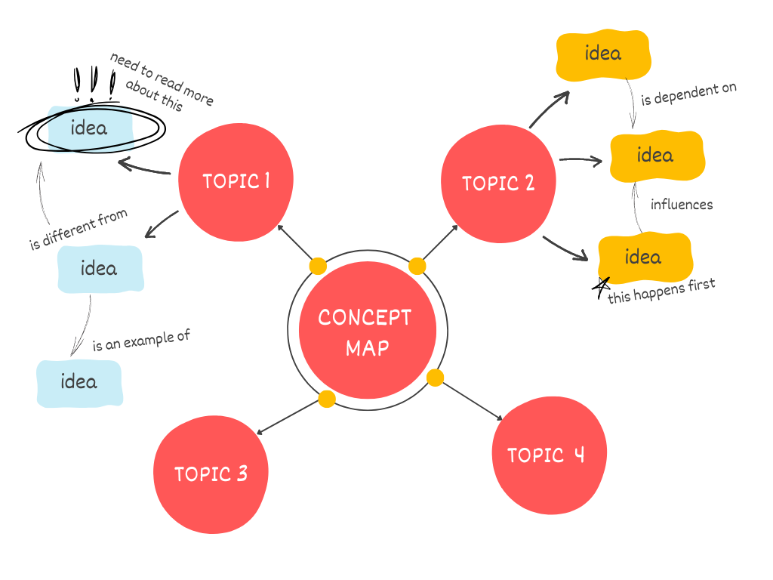

The concepts in these maps are represented as boxes or circles, which relate to lines or arrows. These lines are labeled with linking words and phrases to represent the connections between concepts.

There are different software tools for concept mapping, for example *CmapTools, Mind Manager.*

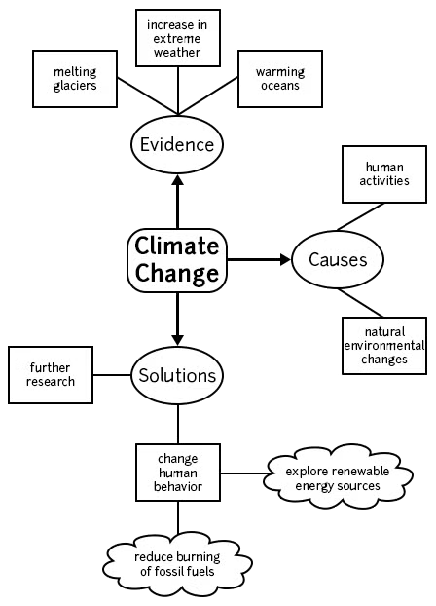

*Example of a Simple Concept Map about Climate Change*

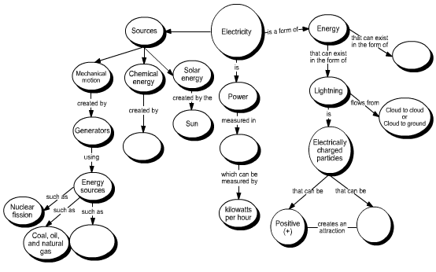

*Example of a concept map showing Electricity.*

**MCQs Solutions**

Q1. Select the suitable answer for the following multiple-choice questions (MCQs).

1. For a problem, we face in real world situations. In what sequence we follow the steps.

I. make some solution.

II. understand the real-world problem.

instruct the computer to behave accordingly.

A

B. 1,111,11

C

D 11,111,1

2. Following are types of computing problems

I. Counting Problems

II. Search Problems

Decision Problem

A I and II

B. I and 111

C. II and III

D. I and II and III

3. Computational thinking is

A. Programming

B. Thinking like a computer

C. Coding

D. Logically solving problems

4. To solve Search problems, we need to

A Provide the moves.

C. Provide the end state.

B. Provide start state.

D. a, b and c

5. The eight queens puzzle is the problem of

A. Sorting

B. Searching

B. Counting

D. Both a and b

6. Finding the location of the element with a given value is

A Search

B. Traversal

C. Sort

D. None of above

7. In IPO Charts, we have

A. Input, Plan, Output

B. Input, Program, Output

C. Input, Process, Output

Answers

D Input, Proceed, Output